**CARE**

*Developer Guide*

|  |  |  |
| --- | --- | --- |
| **Faculty.** | **Bakhtawar Siraj** | |
| **Batch.** | **2210f3** | |
| **Serial No.** | **Enrollment Number** | **Student Name** |
| 1. | *1425944* | M.Danish Asif |
| 2. | *1423510* | M.Anwar Khan |

1. **Admin** :

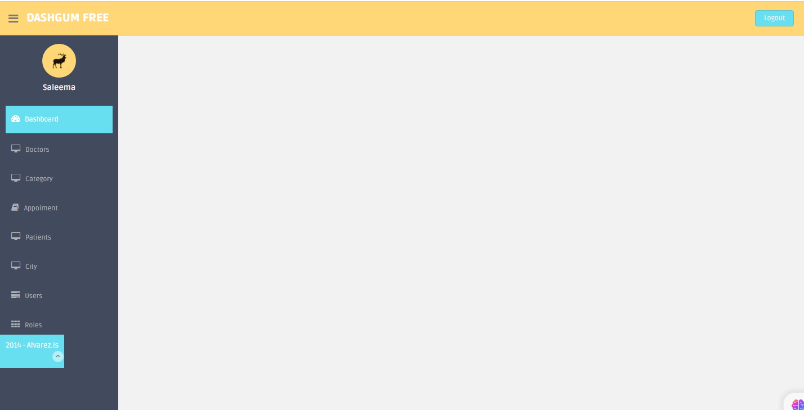

Appointment:

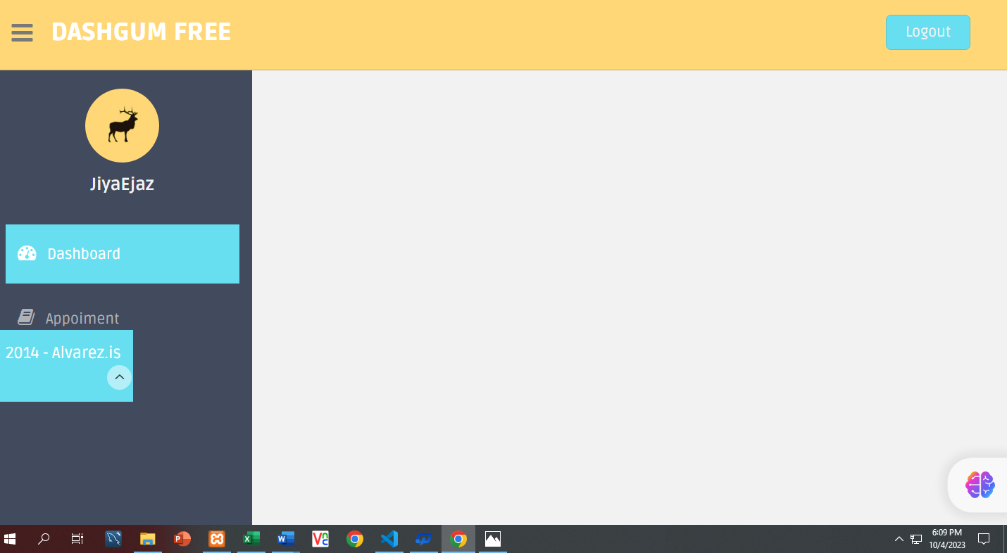

Doctor Panel:

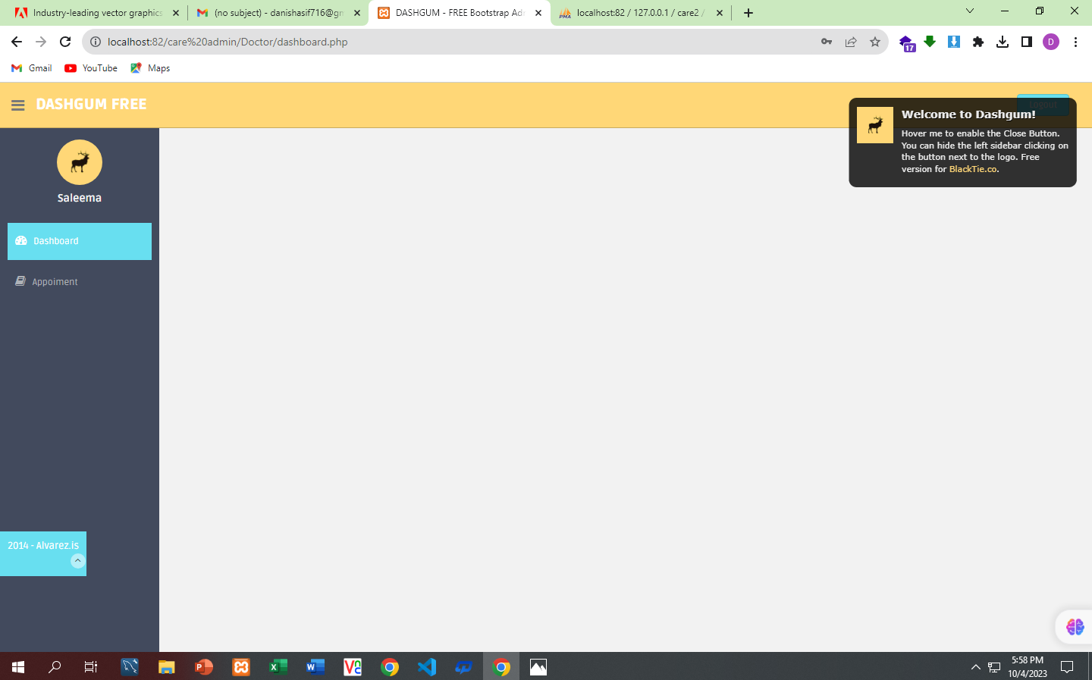

User Login/Signup:

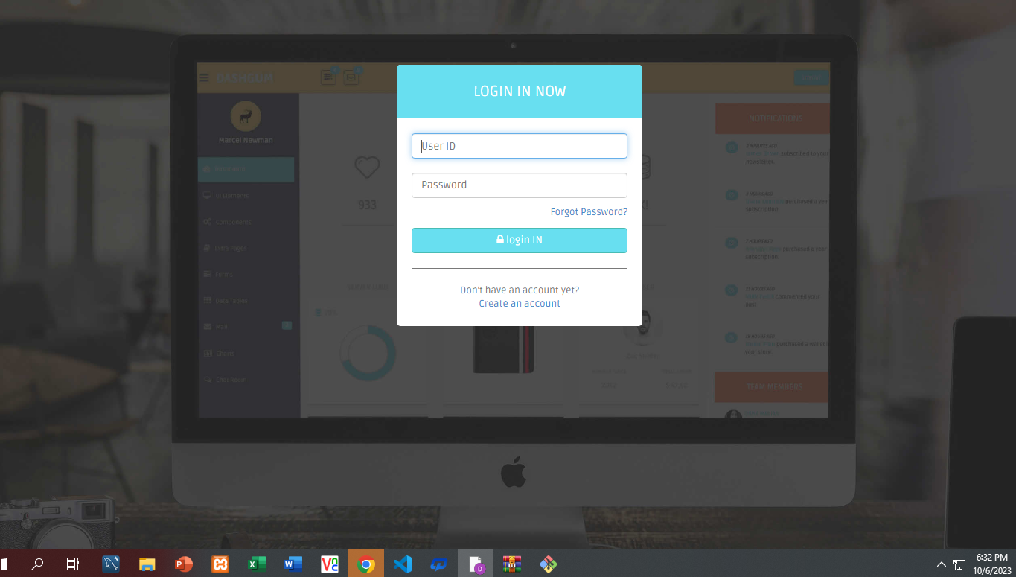

User Page:



Appointment.php:

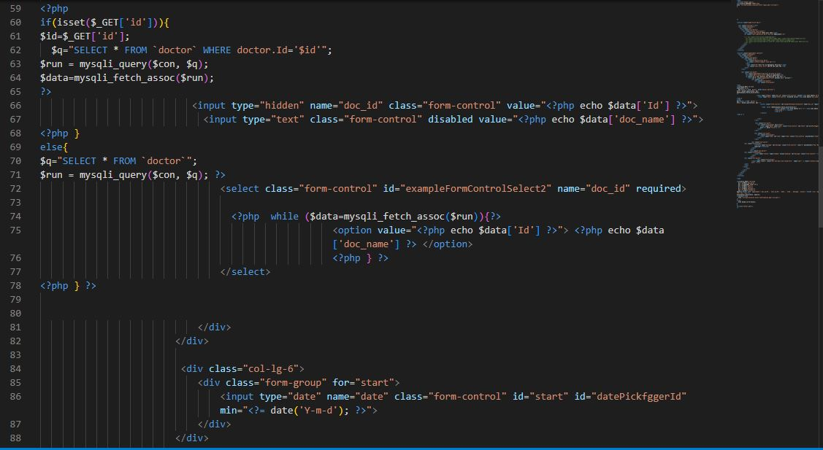

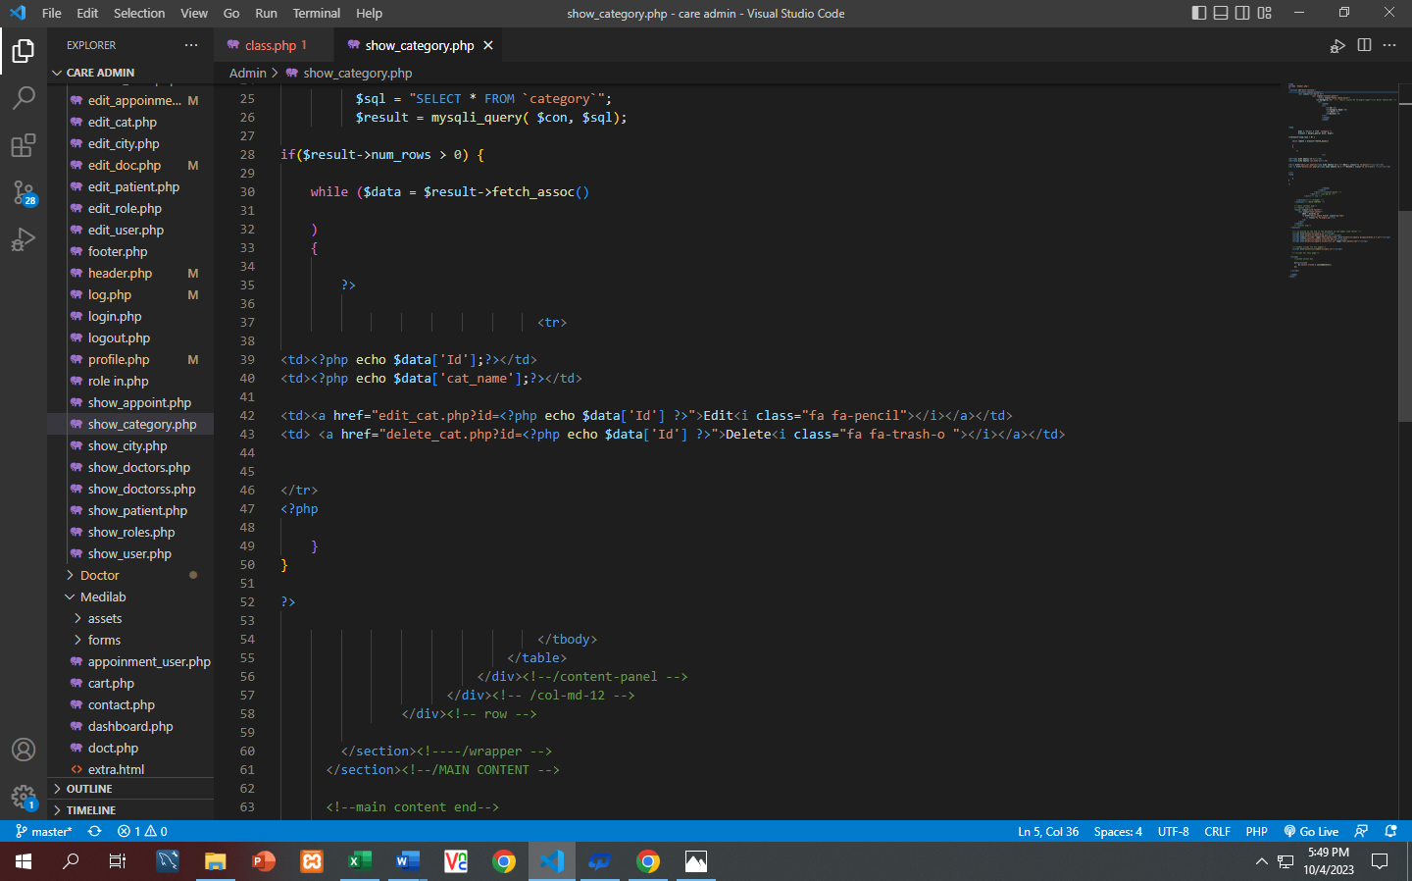

Doctor.php:

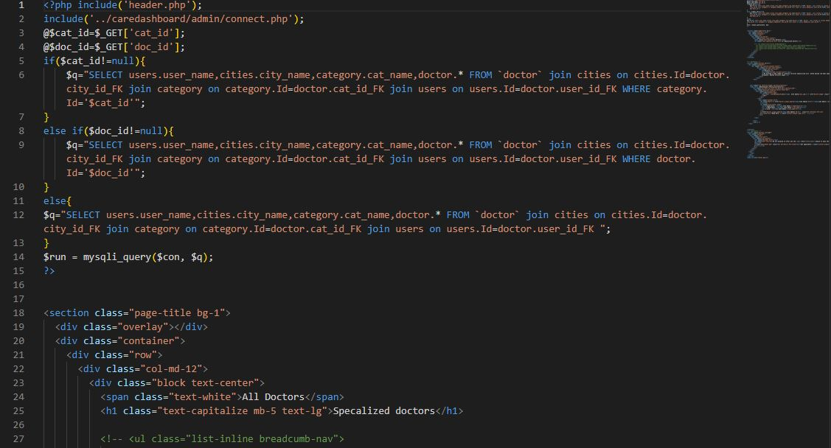

Index.php:

